Stakeholder Identified – Insurance companies and Government agencies

Dashboard 1 – Reported locations and types of Collisions and Injuries occurred Overview

According to the data provided, there are many reported locations and types of collisions and injuries that occur on the roads, highways, and streets. Some of the common types of injuries are Fatal, Incapacitating , No injuries/unknown and non-incapacitating accidents. These accidents can result in different types of collisions ranging from 1 car, 2 cars, 3+ cars, Bus, Cyclist, Moped/Motorcycle and Pedestrian which can be involve in minor cuts and bruises to severe and life-threatening injuries such as broken bones, spinal cord injuries, traumatic brain injuries, and even death.

Stakeholders involved in these collisions and injuries include insurance companies and government agencies. Insurance companies play a crucial role in providing coverage and financial protection for drivers, passengers, and pedestrians involved in accidents. They are responsible for investigating the claims, assessing the damages, and providing compensation to the victims.

Government agencies such as the Department of Transportation, National Highway Traffic Safety Administration, and local law enforcement agencies are responsible for ensuring road safety and reducing the number of accidents on the roads. They are involved in collecting data on collisions and injuries, enforcing traffic laws and regulations, and implementing safety measures such as installing traffic signals, road signs, and speed limits.

Overall, the stakeholders involved in collisions and injuries are essential in preventing accidents, reducing the number of injuries and fatalities, and providing support and compensation to victims and their families. This dashboard will help them to identity the Streets that should be repaired or worked on where traffics can be diverted in the Monoroe County.

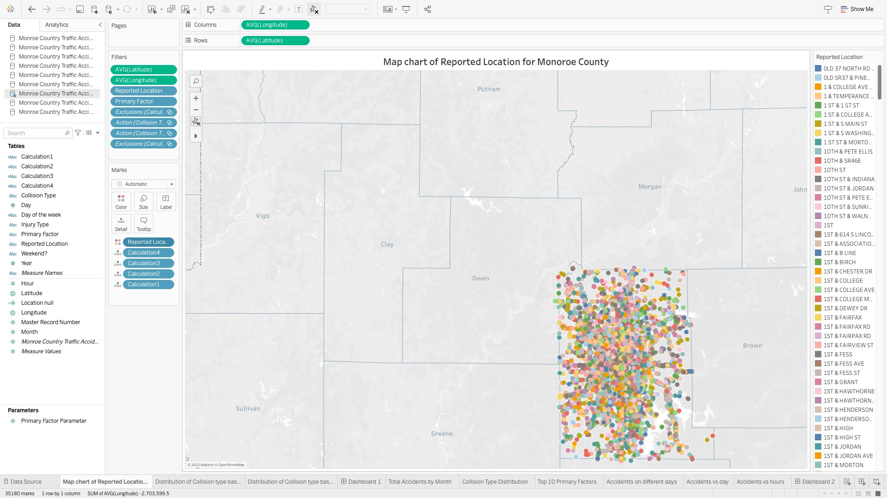

Worksheet 1 – Map-chart of Reported Locations for Monoroe County.

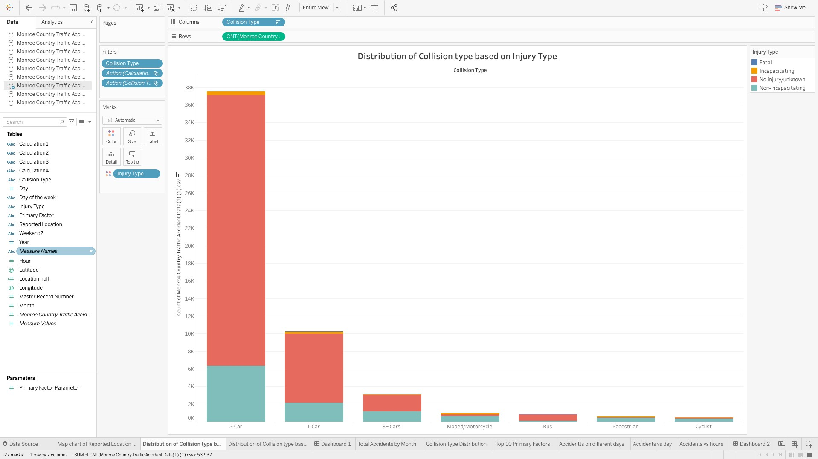

Worksheet 2 – Distribution of Collision type based on Injury Type

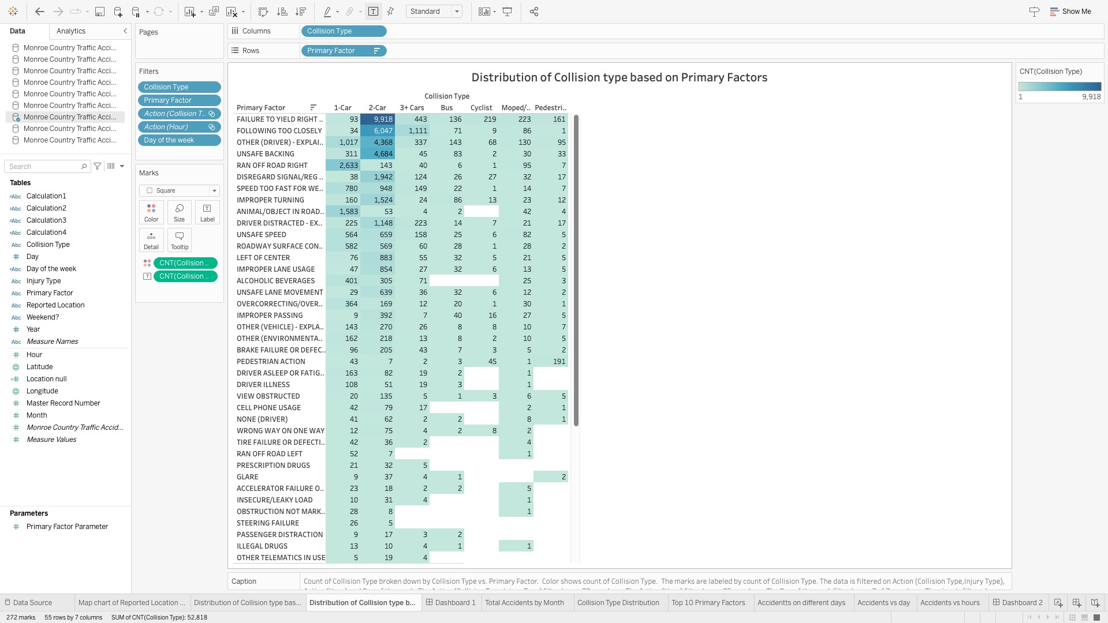

Worksheet 3– Distribution of Collision type based on Primary Factor

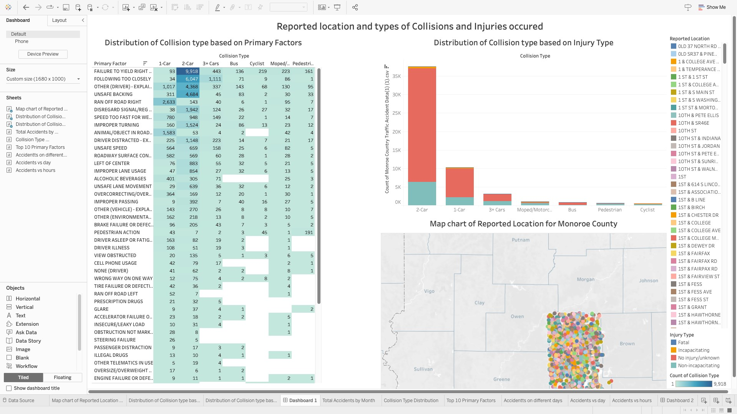

Dashboard 1 – Reported Location and types of Collisions and Injuries occurred

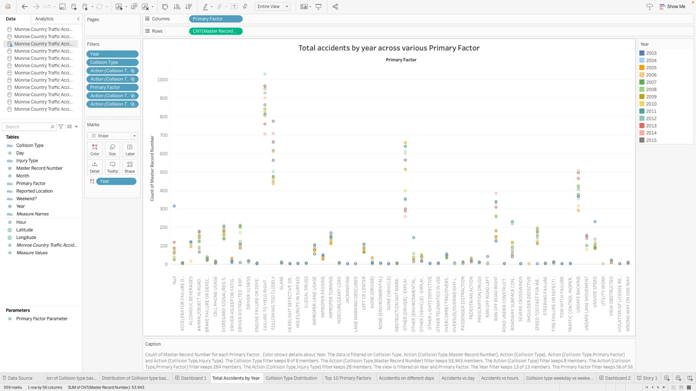

Worksheet 4– Total accidents by year across various Primary Factor

The graph shows the distribution of count of accidents for various years across various primary factors. As depicted in the graph, topmost point in blue color shows the primary factor as failure to yield right of way for the year 2004. When the stakeholder peeks into the data, they will know which primary factor is causing the highest number of accidents. The stakeholder can use visualization to bring in specific measures that control these kinds of factors which can reduce the accidents.

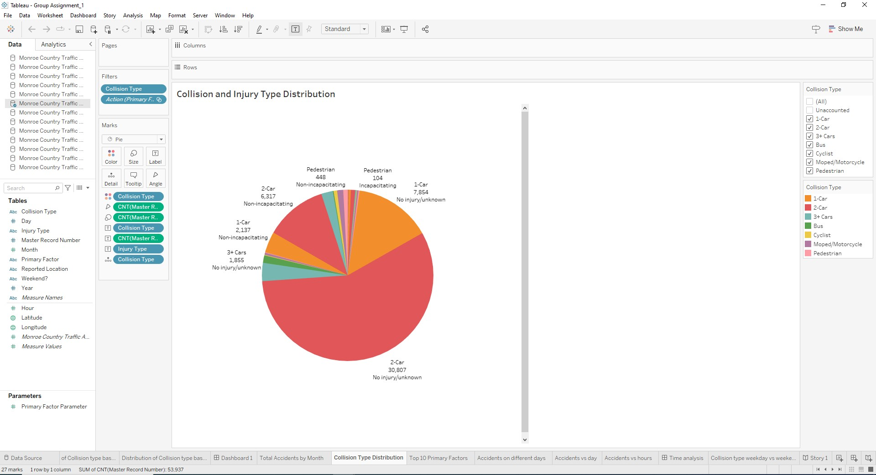 Worksheet 5-Collision and Injury type distribution

The graph shows the distribution of collision types along with their respective injury types recorded due to the number of accidents. When the stakeholder peeks into the pie chart, they will know what kind of injuries are happening across the various collision types. The count of the accidents will allow the stakeholder to make informed decision about the necessary measures to be taken when there is a fatal injury type. For example, the government agencies can set up ambulance zones so that fatal injuries can be averted.

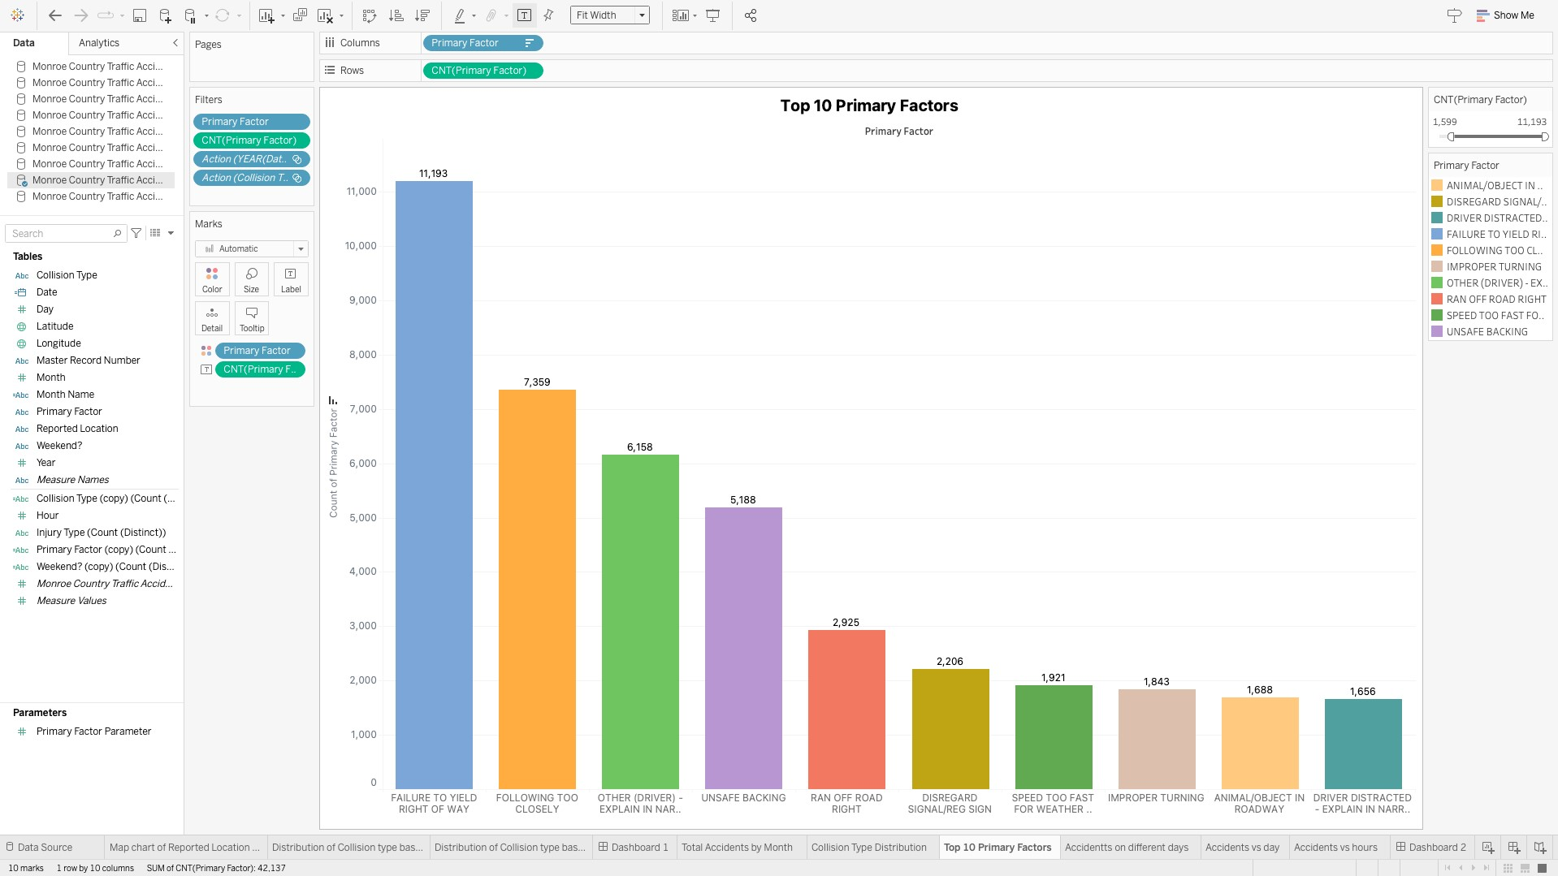

Worksheet 6– Top 10 Primary Factor

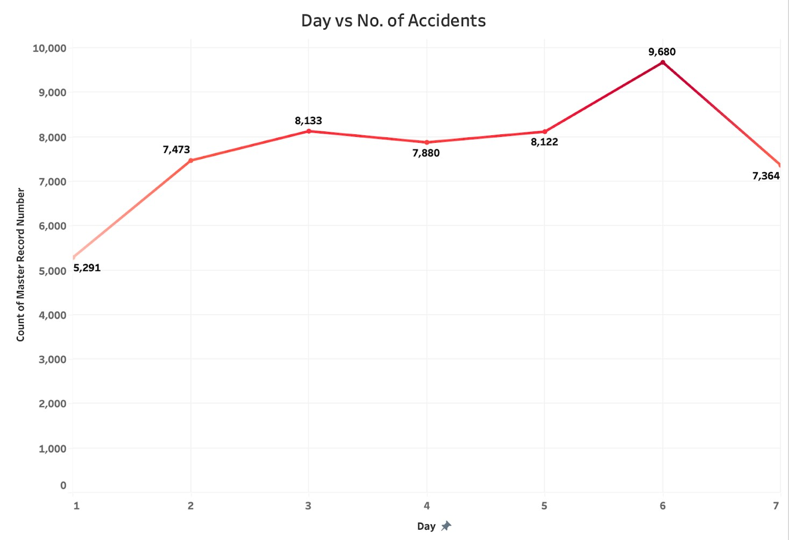

Worksheet 7– Day vs No. of Accidents

The Daily Distribution chart could help identify any patterns or trends in accidents based on the day of the month. For example, if there are more accidents on weekends than weekdays, this could suggest that factors such as higher traffic volume or increased alcohol consumption may be contributing to the higher accident rates on those days.

The chart above shows that the highest no. of accidents occurred on the 6th day, which is a Saturday, suggesting high accidents due to increased alcohol consumption or higher traffic volume.

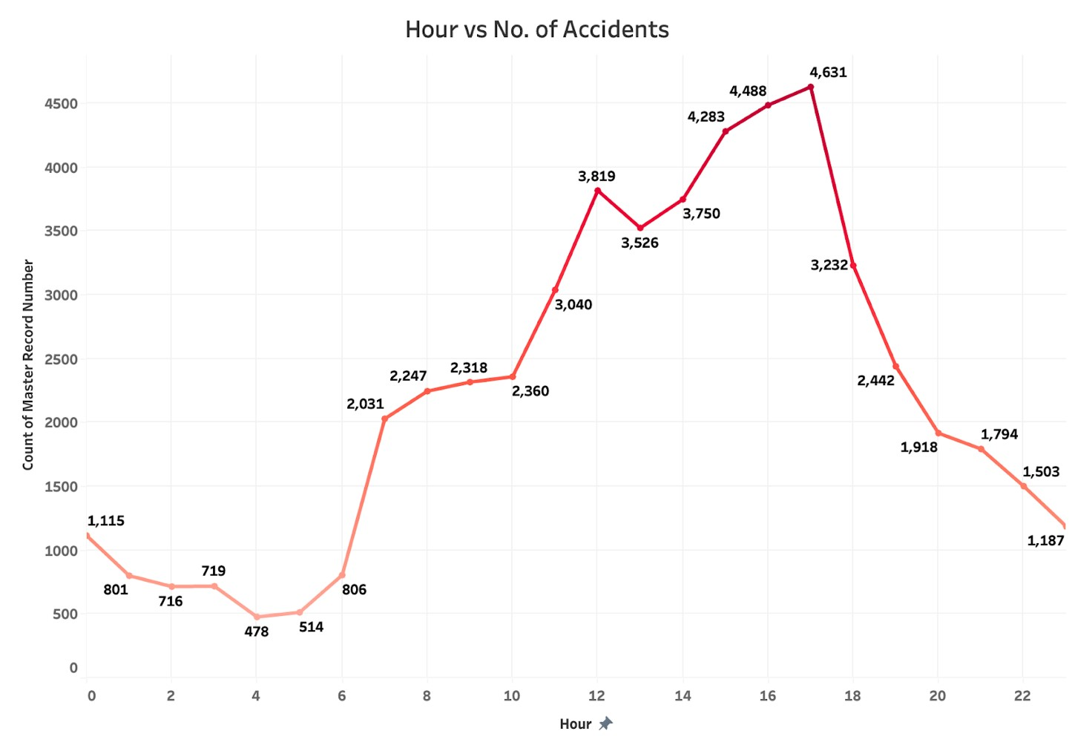 Worksheet 8– Hour vs No. of Accidents

The Hourly Distribution chart could be used to identify peak hours or time periods with higher accident rates. For example, if there is a spike in accidents during rush hour, this could suggest that traffic congestion or driver fatigue could be contributing factors.

The chart above shows that most no. of accidents have taken place during the day from 12 pm to 7pm suggesting rush hour or traffic congestion.

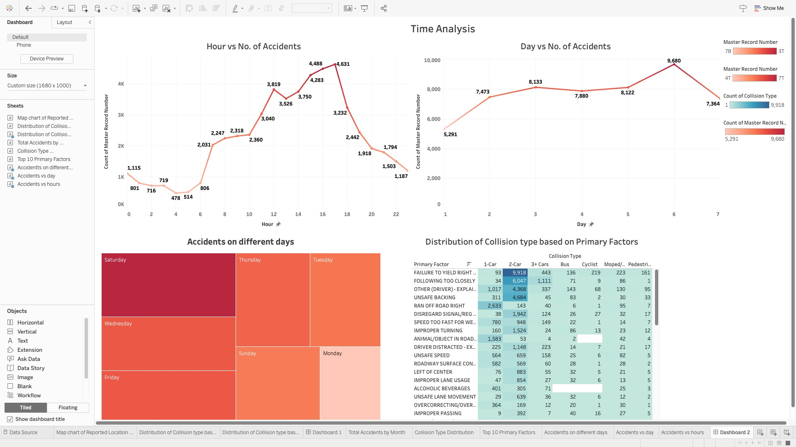

Dashboard 2 – Time Analysis

The Dashboard gives us a great visualization of the accidents that have taken based in a time sensitive manner which involves accidents according to the hours of the day, accidents according to the day of the week. It also tells us about the type of collision in a time sensitive manner. This dashboard will help us determine the exact trend according to the day and the hours by selecting a single or multiple types of collisions.

Weekend vs. Weekday Accidents: A grouped bar chart comparing the number of accidents on weekends versus weekdays, with separate bars for weekends and weekdays. This could help identify any differences in accident patterns between weekends and weekdays.

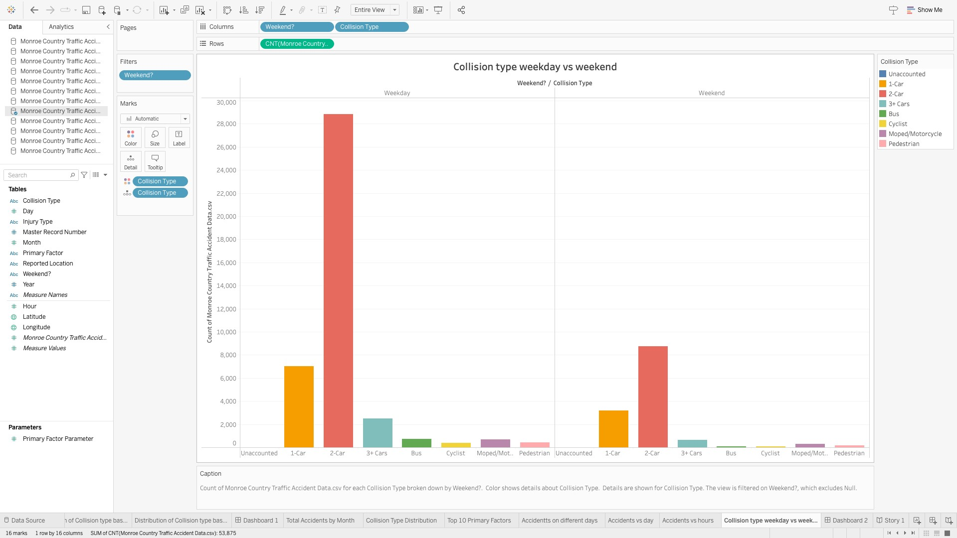 Worksheet 9 -Collision type weekday vs weekends

The collision type during the weekdays and weekends are plotted using the bar graph. The number of accidents have been plotted along the Y-axis and the collision type during the weekdays and weekends are plotted along the X-axis. From the information above, we can say that the 2-car collisions happened the most during the weekend and weekdays followed by the 1 car collision.